Internal Assessment Resource
Science Level 1
EXPIRED
This resource supports assessment against:
Achievement Standard 90941 version 3
Investigate implications of electricity and magnetism for everyday life
Resource title: Too Much Power
4 credits
This resource:
- Clarifies the requirements of the standard
- Supports good assessment practice
- Should be subjected to the school’s usual assessment quality assurance process
- Should be modified to make the context relevant to students in their school environment and ensure that submitted evidence is authentic

Date version published by Ministry of Education | February 2015 Version 3  To support internal assessment from 2015
Quality assurance status | These materials have been quality assured by NZQA.  NZQA Approved number A-A-02-2015-90941-02-4589
Authenticity of evidence | Teachers must manage authenticity for any assessment from a public source, because students may have access to the assessment schedule or student exemplar material.  Using this assessment resource without modification may mean that students’ work is not authentic. The teacher may need to change figures, measurements or data sources or set a different context or topic to be investigated or a different text to read or perform.

Internal Assessment Resource
Achievement Standard Science 90941: Investigate implications of electricity and magnetism for everyday life
Resource reference: Science 1.2A v3
Resource title: Too Much Power
Credits: 4
Teacher guidelines
The following guidelines are designed to ensure that teachers can carry out valid and consistent assessment using this internal assessment resource.
Teachers need to be very familiar with the outcome being assessed by Achievement Standard Science 90941. The achievement criteria and the explanatory notes contain information, definitions, and requirements that are crucial when interpreting the standard and assessing students against it.
Context/setting
This assessment activity requires students to show awareness of an aspect of electromagnetism that has an impact on everyday life. They will report on the results of a practical experiment with parallel circuits. The report will explain the impact of plugging additional resistors into the same circuit, or, in other words, how current varies in a household power socket for different combinations of appliances.
This assessment is based on the DC electricity topic of Electricity and Magnetism and before they begin the task, students need to know:
- how to connect simple series and parallel circuits (a simple parallel circuit is one in which there is no resistor in series with the source)
- how to use power packs, fuses, resistors, and electrical meters
- that current is inversely proportional to resistance for a constant voltage (qualitative knowledge of Ohm’s law V=IR)
- that the heating effect in a wire depends on its resistance and therefore the current through it
- that heat is proportional to power, and power is proportional to current for constant voltage (P = IV), therefore if voltage is constant, increasing total resistance will cool a circuit and decreasing total resistance will heat a circuit
- that adding resistance in series increases the total resistance of the circuit, which lowers the current for a given voltage (total resistance is the sum of each resistance in a serial circuit)
- that adding resistance in parallel lowers the total resistance of the circuit, which increases the current and heat for a given voltage (total resistance is not the sum of each resistance in a parallel circuit, rather, 1/R_{tot} = 1/R₁ + 1/R₂ + … + 1/R_{n} for n resistors in parallel).
Conditions
Students will require two periods or more of practical work, then a further two periods for collating the information and writing the report.
Students should work in groups of no more than three to gather the required experimental results. Students will work independently to write their reports.
Resource requirements
Provide each group with a power pack, three resistors of significantly different resistance, an ammeter, a voltmeter, and connecting wires. Choose resistors that will give a reasonable range of results, e.g. 2Ω, 4Ω, and 8Ω.
Adapt or provide copies of the circuit diagram in Student Resource A.
Additional information
Recommended background teaching topics include fuses, circuit breakers, and power packs.
Information for students about circuits can be found at:
- PhysicsLAB: http://dev.physicslab.org/Document.aspx?doctype=3&filename=DCcircuits_IntroductionDC.xml
- The Physics Classroom: http://www.physicsclassroom.com/class/circuits/U9L3c.cfm
Internal Assessment Resource
Achievement Standard Science 90941: Investigate implications of electricity and magnetism for everyday life
Resource reference: Science 1.2A v3
Resource title: Too Much Power
Credits: 4
Achievement | Achievement with Merit | Achievement with Excellence
Investigate implications of electricity and magnetism for everyday life. | Investigate, in-depth, implications of electricity and magnetism for everyday life. | Investigate, comprehensively, implications of electricity and magnetism for everyday life.
Student instructions
Introduction
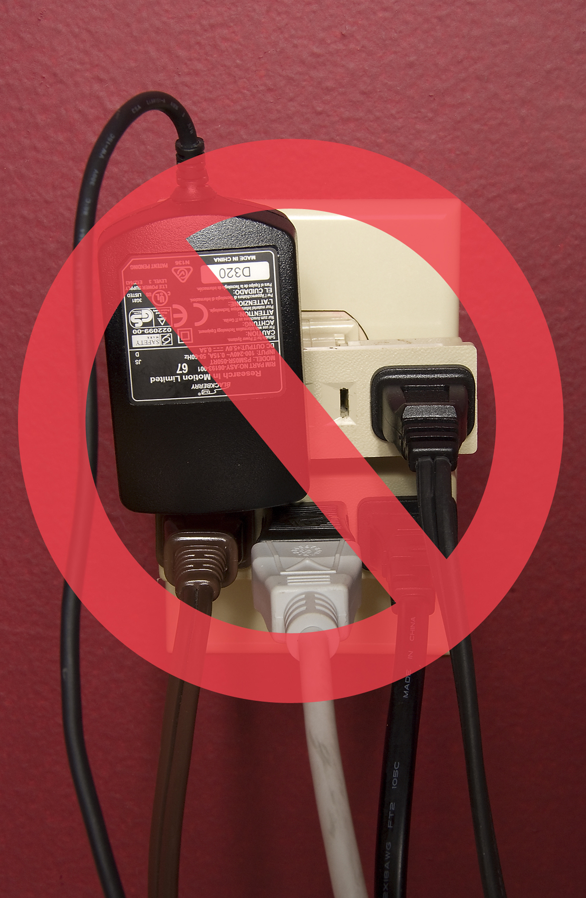
People often use adapters to plug several appliances into the same power socket.
This assessment activity requires you to investigate and explain under what conditions plugging multiple appliances into the same power socket would be dangerous.
You will work in groups of up to three students to carry out experiments and gather data.
You will prepare your report individually.
You will have four to five class periods to complete this work. At the end of each period you will hand in the work you have done. It will be returned to you at the start of the next period.
You will be assessed on how well you are able to use data to explain the impact(s) of plugging additional appliances into a circuit.
You will not be assessed on the process you use to gather your data.
Task
Complete all parts of this task.
Preparation
The wires that carry current to a power socket are behind the walls of the room. The circuit diagram in Student Resource A shows the wiring between the mains power supply and the socket in the wall. Appliances plugged into the same socket connect in parallel.
Imagine someone has plugged three appliances into the power socket shown in Student Resource A – e.g. a microwave, a blender, and a toaster.
Copy the circuit in Student Resource A and complete the circuit, showing how the three appliances are connected.
Gather data
Your teacher will supply you with a power pack (the mains supply), three different resistance resistors (the appliances), an ammeter, a voltmeter, and connecting wires.
In a group of up to three students, set up and carry out an experiment that models the appliances being plugged into the socket, one after the other.
Record your data in an organised way. Make sure each member of your group agrees on and records the same measurements, with appropriate units.
Refer to Student Resource B for further guidance.
Prepare a report
Working on your own, write a report that shows how the results of your experiment explain the impact that plugging additional appliances into the same circuit will have on everyday life.
In your report, make sure you use scientific statements, show calculations, and state units, as appropriate.
Include your data with your report, for assessment.
Refer to Student Resource B for further guidance.
Student Resource A: Circuit diagram

Student Resource B: Further guidance
Gathering data
Your data should allow you to determine:
- how the currents in the different parts of the circuit change as each additional appliance (resistor) is plugged in
- how the voltage across the components in the circuit changes
- whether it matters in which order you connect the appliances (resistors)
- which combinations of one, two, or three appliances are safer than others if the temperature of the wall wires depends on the current flowing through them.
Your report
In your report, make sure you:
- make appropriate inferences from the data about safety. For example, you could explain under what circumstances you might expect that plugging an additional appliance will or will not be dangerous
- link the data you have gathered to scientific theory you have been taught in class
- suggest a safety feature that could be built into the circuits of a house to prevent accidents from happening, where the feature should be connected, and how it might work.
Assessment schedule: Science 90941 Too Much Power
Evidence/Judgements for Achievement | Evidence/Judgements for Achievement with Merit | Evidence/Judgements for Achievement with Excellence
The student investigates implications of electricity and magnetism for everyday life.  Working in a group of up to three, the student carries out a series of experiments and gathers data.  The data enables the student to describe the effect of plugging additional appliances into the circuit provided by the teacher (see the Student Resource A diagram).  In their report, the student shows awareness of how science is involved in the implication.  The student may link their data to a qualitative statement of Ohm’s law.  The student describes the implications of parallel circuits in their report.  Examples include:  The resistance of the wires turns electrical energy to heat.  Increasing current increases the temperature of the wires inside the wall.  If the current is too high, the heat could cause the insulation to catch fire, which could cause the house to catch fire.  Some appliances draw more current than others.  A fuse/circuit breaker works by melting/tripping and breaking the circuit.  Current in the wall wires increases each time a resistor is added, and/or resistance in the circuit decreases each time a resistor is added in parallel. | The student investigates, in-depth, implications of electricity and magnetism for everyday life.  Working in a group of up to three, the student carries out a series of experiments and gathers data.  The data enables the student to describe the effect of plugging additional appliances into the circuit provided by the teacher (see the Student Resource A diagram).  In their report, the student explains how science is involved in the experiment.  The student may link their data to a qualitative statement of Ohm’s law.  The student explains the implications of parallel circuits in their report.  Examples include:  The heat generated in the wall wiring is linked to power and higher power is linked to increasing current.  At all times, the current in the wall wires is the sum of the currents in the resistors.  The current in the wall wiring is linked to the total of the currents drawn by each appliance and hence the heating of the wire to the number of appliances plugged in.  A fuse/circuit breaker works by melting/tripping inside a non-combustible casing, breaking the circuit or burning at a safe place, as opposed to materials combusting in the walls.  The fuse/circuit breaker must be connected into the wiring behind the wall.  Current from mains supply has to go through the wall wires before it splits at the socket.  Lower resistance appliances cause a higher jump in current when plugged in together.  High resistance (low current) appliances are relatively safe to plug in together.  Current can be kept below a safe level by plugging low resistance (high current) appliances in by themselves. | The student investigates, comprehensively, implications of electricity and magnetism for everyday life.  Working in a group of up to three, the student carries out a series of experiments and gathers data.  The data enables the student to describe the effect of plugging additional appliances into the circuit provided by the teacher (see the Student Resource A diagram).  In their report, the student provides reasons and links these together to clearly explain how science is involved in the experiment.  The student explains, in-depth, the implications of parallel circuits in their report. Students will need to mention that to protect a parallel circuit the protection device needs to be wired in series.  Examples include:  Increasing current is linked to each resistor drawing current independently of the others because the voltage across each resistor is the same.  The addition of each resistor creates an extra path for the current to travel through, a subsequent decrease in the total resistance of the circuit, and hence an increase in the current from the mains supply.  Plugging in multiple low resistance appliances to the same socket causes high current (greater than the current for each appliance on its own).  A greater current delivers more power for the same voltage and hence more heat is generated.  The current in the wall wires is linked to the total of the currents drawn by each appliance and so more high resistance (low current) appliances can be safely plugged in than low resistance (high current) appliances.  The fuse/circuit breaker must be connected into the wiring behind the wall in such a place that makes it accessible so that the fuse can be replaced or the circuit breaker reset.  The increasing current from mains supply is linked to each appliance drawing current independently of the others, or to the addition of each appliance decreasing the total resistance of the circuit.
Final grades will be decided using professional judgement based on a holistic examination of the evidence provided against the criteria in the Achievement Standard.

